10/05/2019

Elval joins the Aluminium Stewardship Initiative (ASI)

«Elval became a member of the international initiative ASI (Aluminium Stewardship Initiative), the standards setting and certification organization that unites leading aluminium companies towards sustainable growth and responsible aluminium production»

Elval announces its membership to the Aluminium Stewardship Initiative (ASI), aligning its efforts towards sustainable growth along with 85 companies in the aluminium sector, worldwide. ASI is a global, non-profit organization that sets standards for sustainable development and certifies production facilities throughout the entire aluminium supply chain.

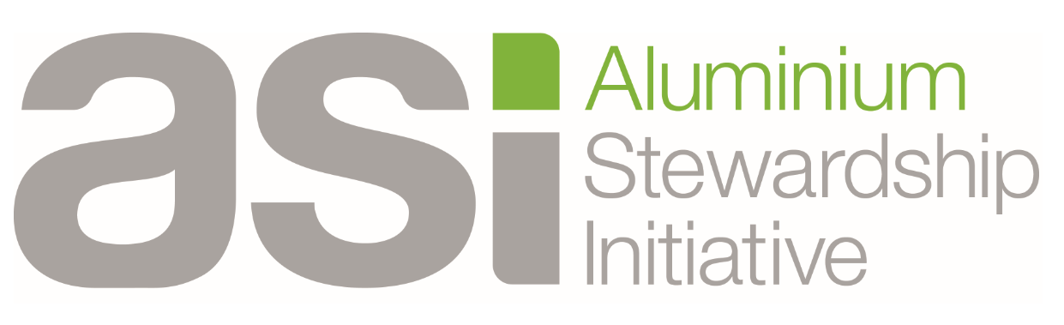

Through its participation, Elval aims to certify its operational processes of responsible production and confirm its commitment to the principles of environmental protection, social responsibility and responsible corporate governance.

The ASI organization has been formed by companies and institutions from the entire aluminium value chain, namely Industry Associations, Civil Societies, Supporters, Final Industrial Users that manufacture aluminium-based products as well as aluminium Production and Transformation manufacturers from the entire supply chain range, from mining up to the manufacture of consumer products.

Nowadays, ASI issues two standards:

- The ASI Performance Standard that incorporates environmental, social and corporate governance criteria throughout the aluminium life cycle. The objective of this standard is to comply with a set of standards common to all stakeholders in the aluminium supply chain in order to ensure the sustainable development and the rational material stewardship.
- The ASI Chain of Custody Standard, offers the link between companies that have certified their operations against the ASI Performance Standard, ensuring that the material integrated in the supply chain, has been processed according to ASI’ principles of sustainable growth.
Elval started its certification process in the ASI Performance Standard, aiming with the highest priority to the immediate completion of the project. The certification audit to the ASI standards will be conducted by prestigious international Αccredited Auditing Firms.

About Elval:
Elval is the aluminium rolling division of ElvalHalcor S.A., one of the leading aluminium rolling manufacturers worldwide and the only one in Greece. For almost 50 years, Elval has been recognised as a trusted partner and innovative aluminium manufacturer, with a broad portfolio of quality products for the packaging, construction, shipbuilding, automotive, energy, industrial and HVAC markets. Through an established global commercial network across 21 countries, Elval exports approximately 80% of its production to more than 60 countries and offers reliable and competitive solutions that meet the requirements of the most demanding global customers. For more information about Elval, please visit the website www.elval.com

About ASI (Aluminium Stewardship Initiative)
The Aluminium Stewardship Initiative (ASI) is a standards setting and certification organisation that recognises and fosters the responsible production, sourcing and stewardship of aluminium. As a member-based, global initiative, ASI is the result of producers, users and stakeholders in the aluminium value chain coming together to build consensus on ‘responsible aluminium’. ASI continues to seek engagement with commercial entities and stakeholders in the aluminium value chain from across the world. For more information about ASI please visit the website https://aluminium-stewardship.org/

